|  |
| --- |
| **UNIVERSITY MALAYSIA TERENGGANU**  **FACULTY OF OCEAN ENGINEERING TECHNOLOGY & INFORMATICS**  **[CSM3103]**  **FRONT-END PROGRAMMING**  **LAB REPORT**  **[Lab 4]**  **Prepared by:**  Muhammad Irfan Hakim bin Saharul Redzuan  (S62113)  **Prepared for:**  Dr. Rabiei b. Mamat  [**BACHELOR OF SCIENCE COMPUTER(MOBILE COMPUTING)** ]  SEMESTER II 2022/2023 |

**Task 1**

1. i- What is id button and input field?

* Id button is button change
* Input field is input color

ii- What happen when we clicked change button and why?

* Nothing occurs because this button doesn't have a function.

Source code (before modify)

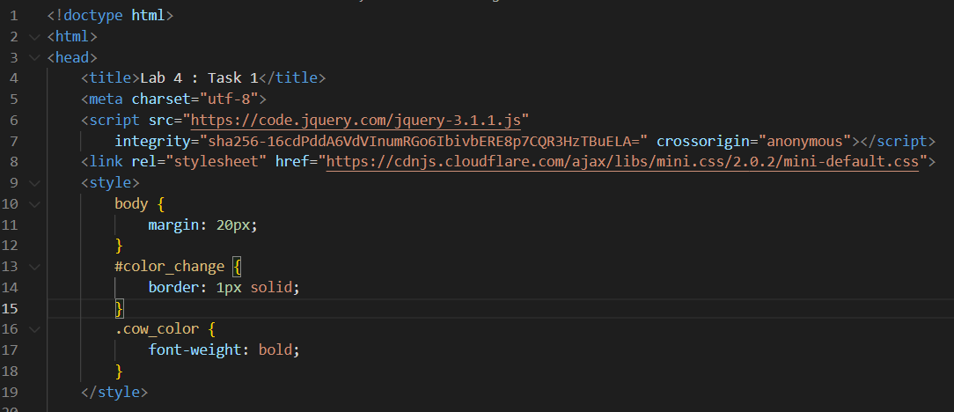

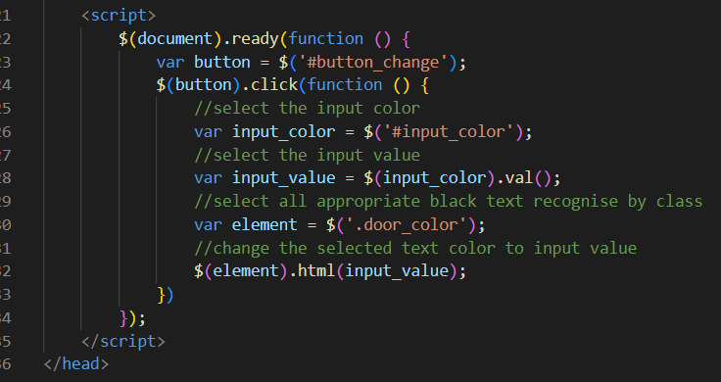

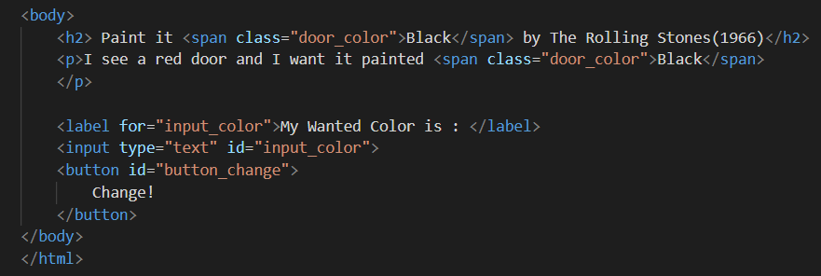

Output :

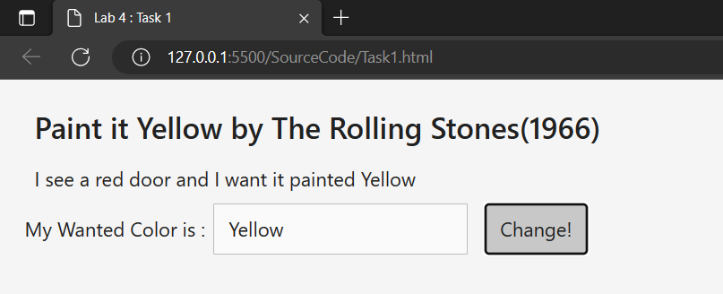

Source code (after modify)

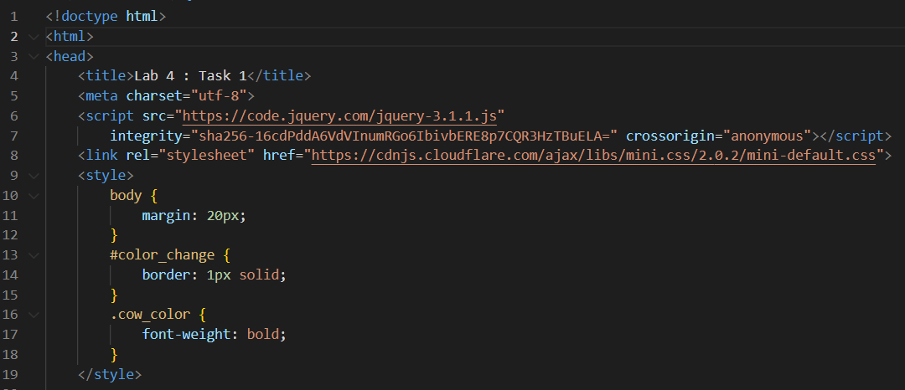

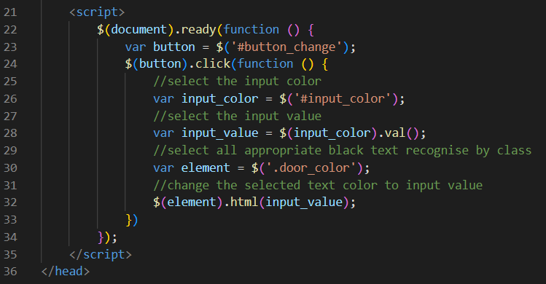

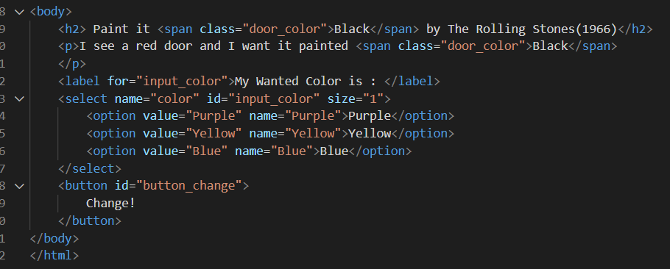

Output :

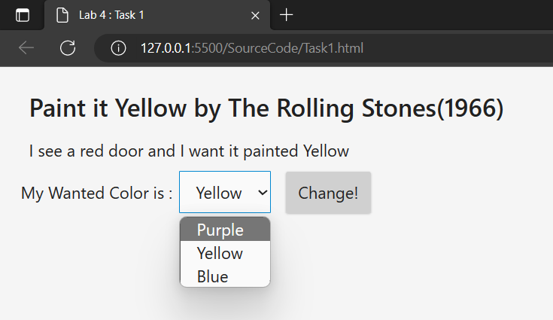

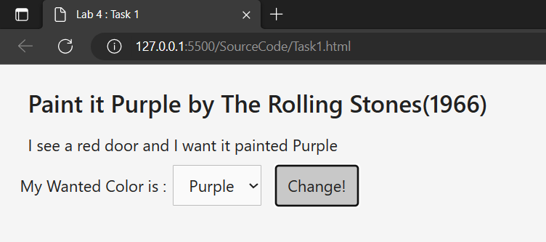

**Task 2**

1. What are id’s that exist in the code above?

* id = “boxes”
* id = “toggles”

1. Open the file inside browser, what have you see in the browser?

The source code of toggles button

1. Click any button, what happened? Why

The button not function because not have any javascript on it

Source code (after modify)

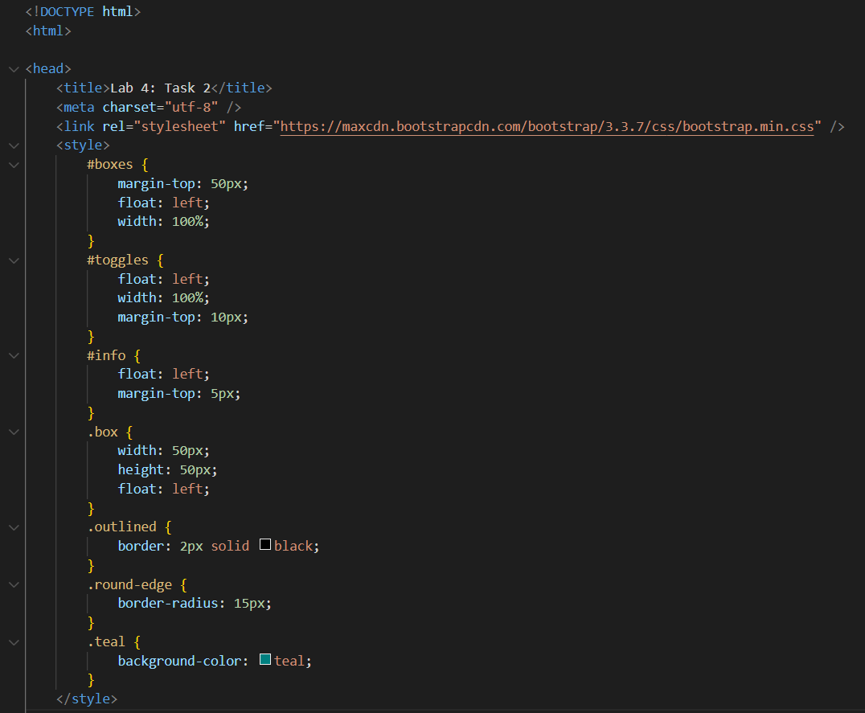

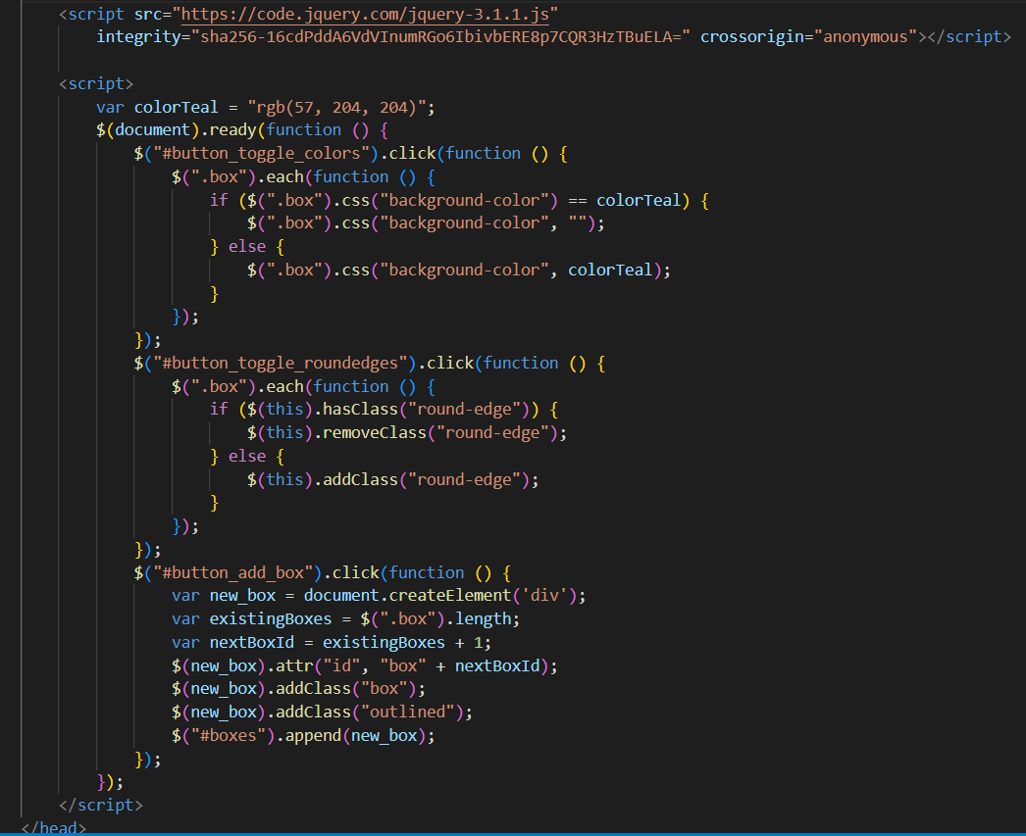

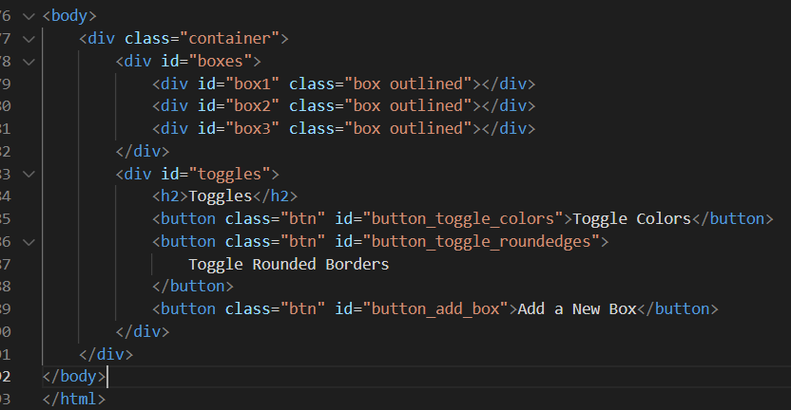

Output :

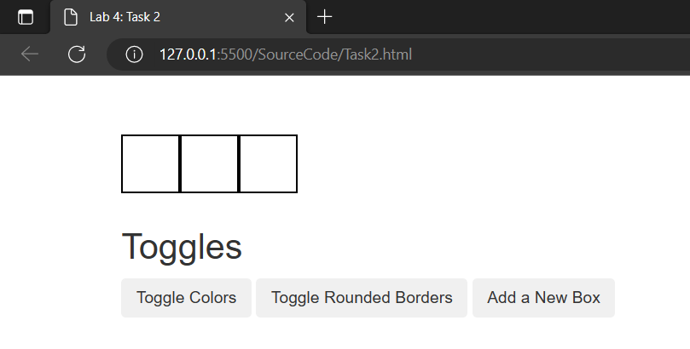

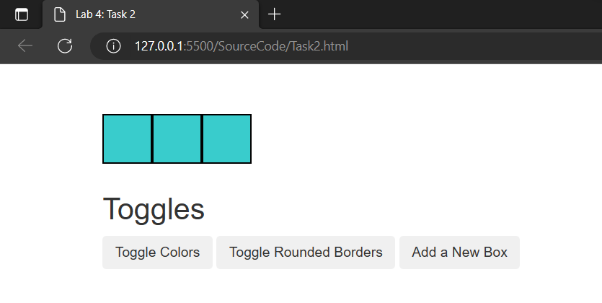

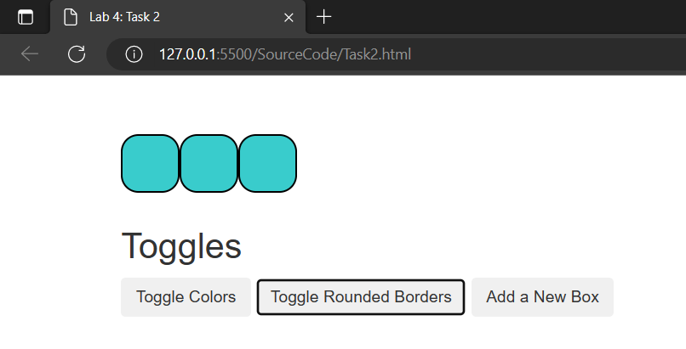

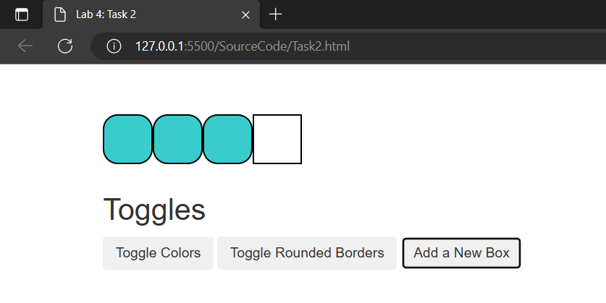

**Task 3**

1. Determine the id’s of each elements

* id="button_toggle_colors"
* id="button_toggle_roundedges"
* id="button_add_box

1. Recognise any input element that associated with the form iii. Your Task are

* Add DatePicker
* Use selectable interaction
* Use Sortable widget
* Use the tooltip

**Source code**

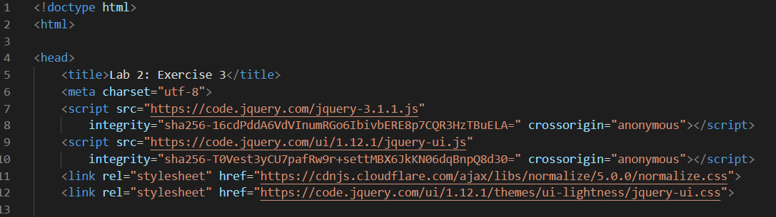

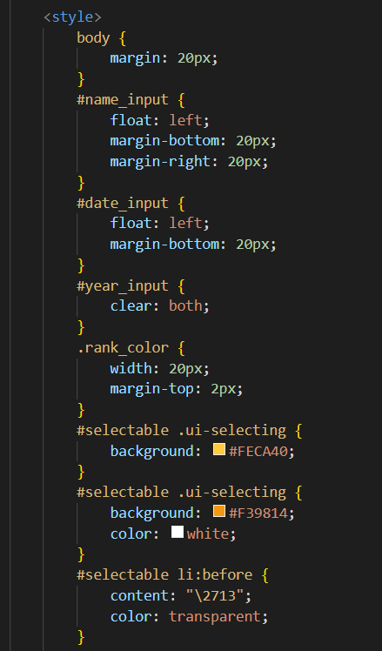

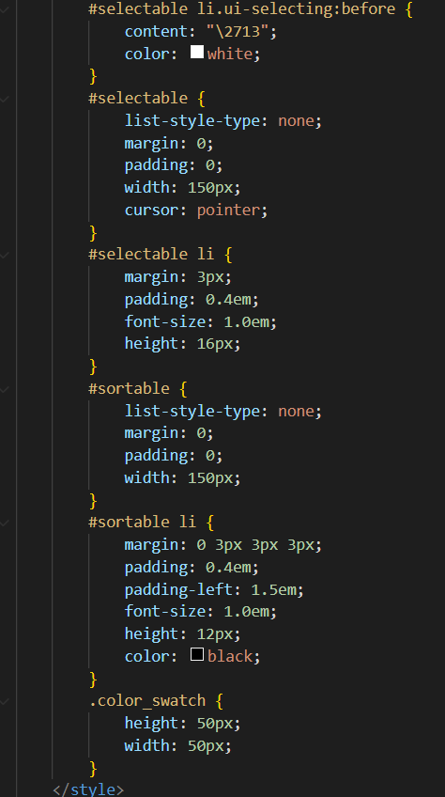

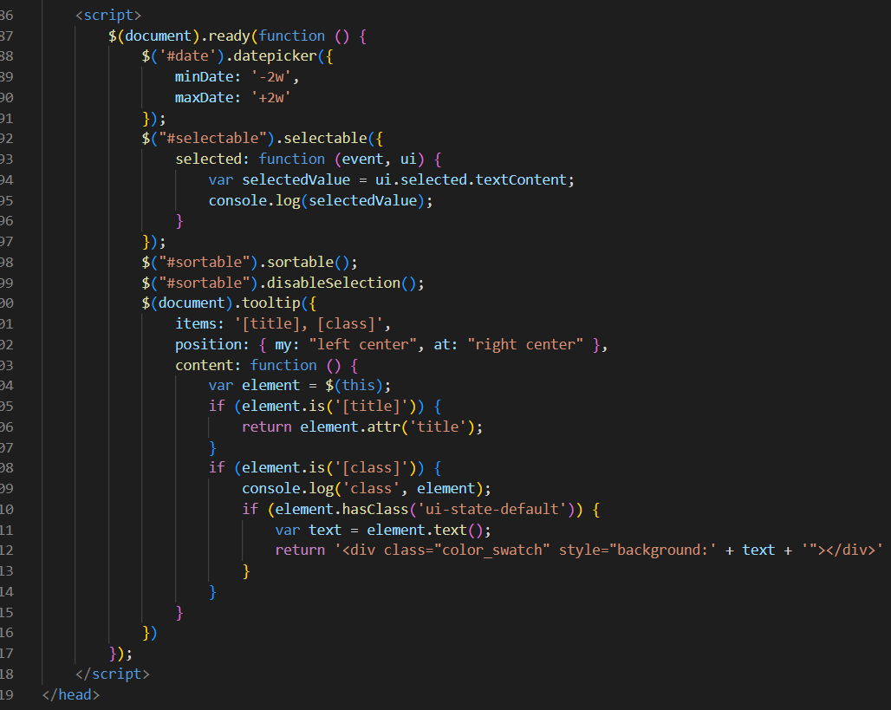

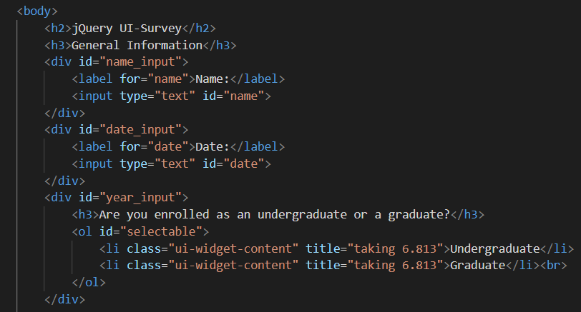

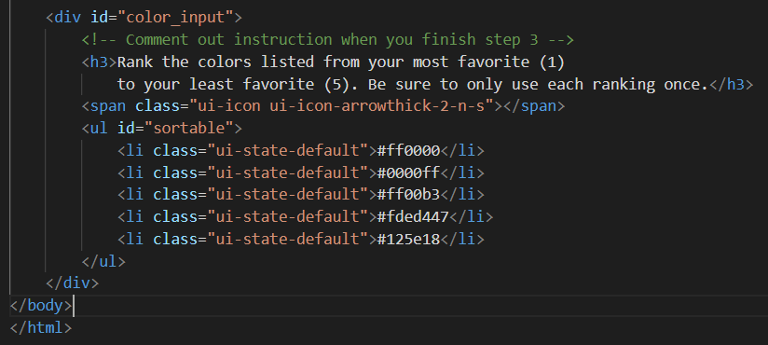

Output :

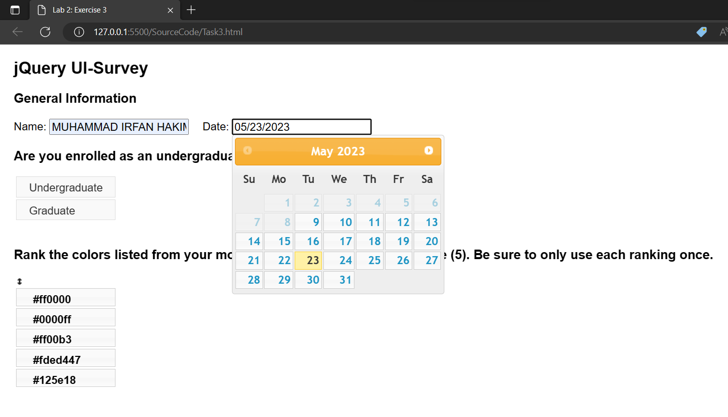

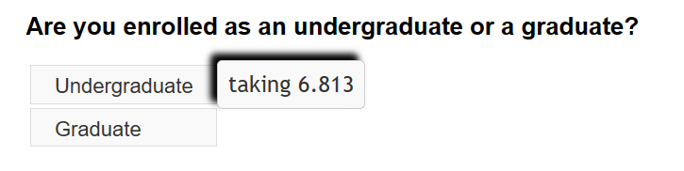

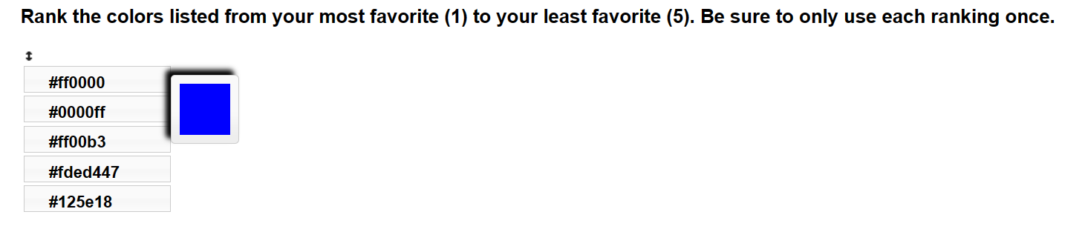

**Task 4**

Source code

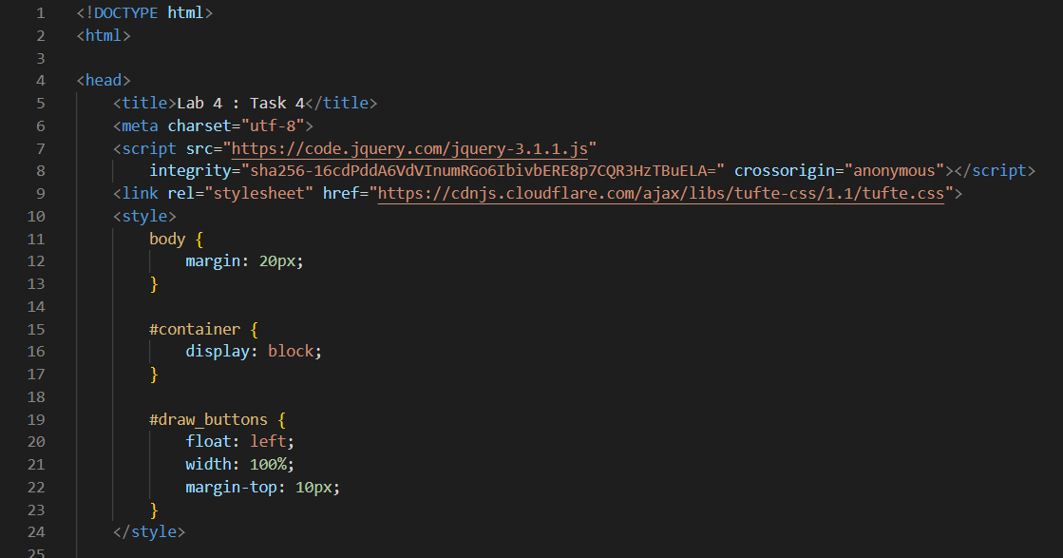

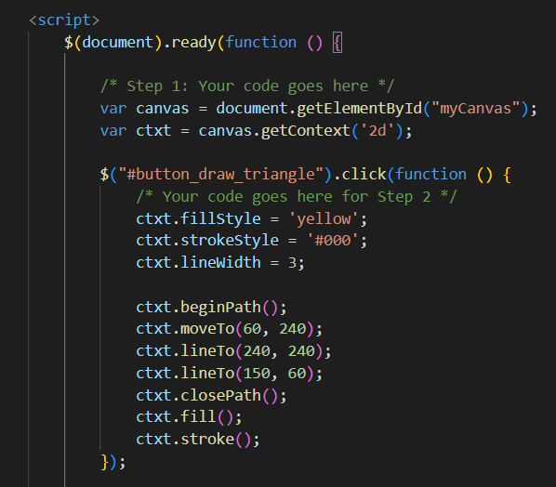

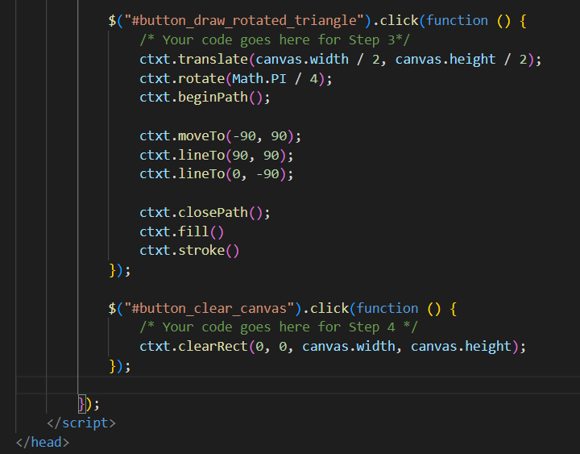

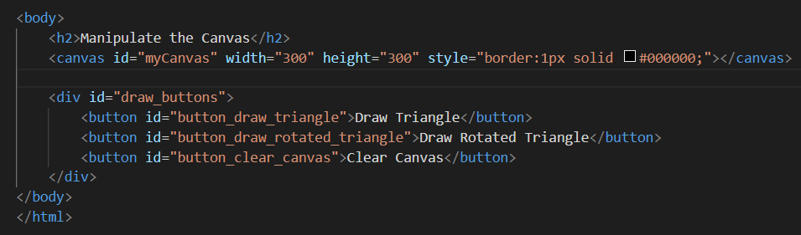

Output :

